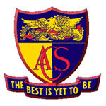
ECHO Readership Profile & Advertising Rates
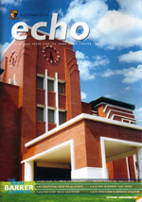
What is the ECHO?
The ACS Board of Directors publishes the Echo magazine four times a year. It is distributed in-class to students of the seven Anglo-Chinese Schools and has a guaranteed circulation of 11,500 copies. It is used as a tool to engage the interest, support and participation of students, their parents and old boys in the ACS family of schools.

Who Reads It?
The Echo has a readership estimated at more than 25,000 making it the largest circulated school magazine in Singapore. The magazine is aimed at informing, entertaining, enriching and motivating its student readers.
It reaches out to students in two Primary schools, two Secondary schools, a Junior College and two International schools. Parents read it to stay informed and to keep in touch with the school’s activities and the latest trends in education.

Its Editorial
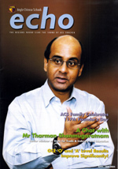
Its editorial content covers a wide range of topics that are of general interest to students, their parents and the old boys of the school and written in a style that gives them a truly enjoyable reading experience. It covers real life issues that are relevant to their lifestyle such as exam stress, time management, peer pressure and most anything to do with those growing years.
Principals, teachers and students also contribute articles that are informative and educational and include sporting and academic achievements of the schools. It is an important source of information for parents, ACS old boys and educators.
Why Advertise in the Echo
The Echo is packaged in a way that appeals to the youth.
The Echo provides an ideal environment in which to promote sports goods, educational products, computers and electronics, entertainment, food and beverages, and generally all those products that target students and their parents.
By advertising in the Echo, you will be reaching an exclusive segment of a vibrant and impressionable youth market and as its circulation is guaranteed, it offers the advertiser genuine value for his advertising dollar.

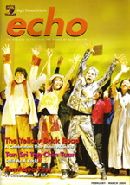
Full Colour, Full Page Advertising Rates
Position Rates
Outside Back Cover $1,850
Inside Front Cover $1,750
Inside Back Cover $1,650
Run of Book $1,550
Series Discounts
2 insertions 5%
4 insertions 10%

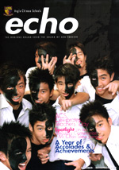
Technical Specifications
Size Depth Width
Full Page Bleed 307mm 220mm
Full Page Trimmed Size 297mm 210mm
Full Page Text Area 277mm 190mm
Artwork: CD in pdf hi-resolution with cropped mark and bleed in CMYK mode

Publication Dates
▪ End February ▪ Early May ▪ Early August ▪ Mid October
Booking Deadlines
▪ 20 January ▪ 07 April ▪ 07 July ▪ 08 September
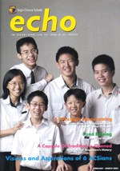
Circulation - 11,500 copies
Anglo-Chinese Junior College 1,700
Anglo-Chinese School (Independent) 2,900
Anglo-Chinese School (Barker Road) 1,500
Anglo-Chinese School (Primary) 1,800
Anglo-Chinese School (Junior) 1,500
Anglo-Chinese School (International) 700
STB-ACS (International) Jakarta 500
ACS Old Boys’ Association &
the ACS Board of Governors 500
Others* 400
* Includes key Ministry of Education personnel, all English & Chinese newspapers in
Singapore and advertisers

For advertising, please contact:
Blue Skies Communications
Tel: (65) 9380-7883 or (65) 9632-1170

